eNSP2.0模拟PPPoE实验

拓扑如下：
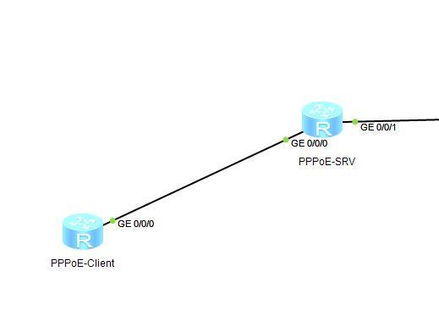

PPPoE服务器上的配置
sysname PPPoE-Server
#
ip pool pool1 //创建地址池用来为客户端分配地址
network 192.168.10.0 mask 255.255.255.0
gateway-list 192.168.10.1
#
aaa //在AAA下配置认证方案和创建用于认证的账号
authentication-scheme system_a
domain system
authentication-scheme system_a
local-user user1@system password cipher huawei
local-user user1@system service-type ppp
#
interface Virtual-Template1 //配置认证虚模板
ppp authentication-mode chap domain system
remote address pool pool1
ip address 192.168.10.10 255.255.255.0
#
interface g0/0/0 //接口上开启PPPOE服务器的功能
pppoe-server bind Virtual-Template 1
#
interface LoopBack100 //模拟公网的地址
ip address 100.100.100.100 255.255.255.0

PPPoE客户端的配置
#
sysname PPPoE-Client
#
dialer-rule //配置拨号规则，IP流量触发PPP拨号
dialer-rule 1 ip permit
#
interface Dialer0 //配置拨号接口 0
link-protocol ppp //协议是PPP
ppp chap user user1@system //配置被认证方的chap账号
ppp chap password simple huawei //配置chap密码
mtu 1492 //修改MTU为1500-8=1492 ，1500是以太网最大传输单元，8是PPP头部长度
ip address ppp-negotiate //配置IP地址采用PPP协商方式获取，即通过服务器的地址池分配
dialer user user1@system //配置拨号用户，这个是非按需拨号时要配置
dialer bundle 1 //配置拨号捆绑的编号 1，1要和下面接口的的配置对应
#
interface g0/0/0
pppoe-client dial-bundle-number 1
#
ip route-static 0.0.0.0 0.0.0.0 Dialer0 //配置用于上网的默认路由，注意出口是拨号接口Dialer0，不用也没法指定下一跳IP
return

如果路由器下面还有PC要上网，还要配置NAT
acl 3000
rule permit ip
inter dialer 0
nat outbound 3000

在客户端测试PPPoE的配置

[PPPoE-Client]dis ip inter bri
Interface IP Address/Mask Physical Protocol
Dialer0 192.168.10.254/32 up up(s)
GigabitEthernet0/0/0 unassigned up down
GigabitEthernet0/0/1 unassigned down down
NULL0 unassigned up up(s)
[PPPoE-Client]ping 100.100.100.100
PING 100.100.100.100: 56 data bytes, press CTRL_C to break
Reply from 100.100.100.100: bytes=56 Sequence=1 ttl=255 time=100 ms
Reply from 100.100.100.100: bytes=56 Sequence=2 ttl=255 time=10 ms
Reply from 100.100.100.100: bytes=56 Sequence=3 ttl=255 time=10 ms
Reply from 100.100.100.100: bytes=56 Sequence=4 ttl=255 time=10 ms
Reply from 100.100.100.100: bytes=56 Sequence=5 ttl=255 time=10 ms
--- 100.100.100.100 ping statistics ---
5 packet(s) transmitted
5 packet(s) received
0.00% packet loss
round-trip min/avg/max = 10/28/100 ms
[PPPoE-Client]dis pppoe-client session summary
PPPoE Client Session:
ID Bundle Dialer Intf Client-MAC Server-MAC State
1 1 0 GE0/0/0 00e0fc03c38b 00e0fc033c76 UP

在服务器上测试PPPoE的配置
<PPPoE-Server>dis ip routing-table
Route Flags: R - relay, D - download to fib
------------------------------------------------------------------------------
Routing Tables: Public
Destinations : 11 Routes : 11
Destination/Mask Proto Pre Cost Flags NextHop Interface
100.100.100.0/24 Direct 0 0 D 100.100.100.100 LoopBack100
100.100.100.100/32 Direct 0 0 D 127.0.0.1 LoopBack100
100.100.100.255/32 Direct 0 0 D 127.0.0.1 LoopBack100
127.0.0.0/8 Direct 0 0 D 127.0.0.1 InLoopBack0
127.0.0.1/32 Direct 0 0 D 127.0.0.1 InLoopBack0
127.255.255.255/32 Direct 0 0 D 127.0.0.1 InLoopBack0
192.168.10.0/24 Direct 0 0 D 192.168.10.10 Virtual-Template1
192.168.10.10/32 Direct 0 0 D 127.0.0.1 Virtual-Template1
192.168.10.254/32 Direct 0 0 D 192.168.10.254 Virtual-Template1
192.168.10.255/32 Direct 0 0 D 127.0.0.1 Virtual-Template1
255.255.255.255/32 Direct 0 0 D 127.0.0.1 InLoopBack0
<PPPoE-Server>dis pppoe-server session all
SID Intf State OIntf RemMAC LocMAC
1 Virtual-Template1:0 UP GE0/0/0 00e0.fc03.c38b 00e0.fc03.3c76
<PPPoE-Server>dis access-user
------------------------------------------------------------------------------
UserID Username IP address MAC
------------------------------------------------------------------------------
145 user1@system - 00e0-fc03-c38b
------------------------------------------------------------------------------
Total 1,1 printed
<PPPoE-Server>

